**Design and Implementation of Automated Elevator Using Programmable Logic Controller**

Shalini Mandal, Subhrajyoti Manna, Sohini Mitra

Under the guidance of Mr. Prakash BanerjeeAssistant professor, E.C.E dept, UEM, Kolkata.

*Department of Electronics and Communication Engineering, University of Engineering and Management, Kolkata, West Bengal. India*

1. **ABSTRACT**

This paper describes the design and implementation of an automatic elevator using PLC. In this growing world due to the rising living standards and tremendous development in architectural engineering for multistoried buildings, the installation of elevators has become an integral part of the infrastructure for vertical movement. So, the control system is essential for smooth and efficient performance in the design of an elevator control system. Hence for more efficient performance and maintenance, more importance is given to the design of an elevator control system. The elevator control system is programmed in a ladder diagram format into the PLC with four outputs corresponding to four inputs. Therefore, it is a real-time control system.

**Keywords:** Elevator, Programmable Logic Controller (PLC), Ladder diagram

**\**

1. **INTRODUCTION**

Elevators are the necessary medium of vertical transportation for humans as well as goods in both the residential environment and the industrial environment. Hydraulic and roped elevators are the two types of elevators in use today. Preliminarily, todays’ traditional elevator control systems work on relay logic. Some of the drawbacks of these systems are: The control system has a high failure rate mainly due to numerous contacts, the complexity of the wiring circuit. In addition, electrical contacts were easy to burn out.

In this control system, the device that is dealt with is a Programmable Logic Controller (PLC). It is a digital computer used for the automation of industrial processes such as control of machinery on factory assembly lines. The controller depends on memory and the input and output terminals [1]. The control system mainly includes two parts, which are the logic control system and the drag control system. Among them, the logic control system is mainly realized by PLC system software. Implementation of PLC in the elevator control system enhances the efficiency of the elevator [2]. Unlike general-purpose computers, the PLC is designed for multiple inputs and outputs arrangements, is immune to electrical noise, and is resistant to vibration and impact. It is the substitute for a relay logic controller [3-4]. Programs to control operations are typically stored in non-volatile memory. PLC has many advantages over other control systems. It is known for its flexibility, low cost, operational speed, reliability, ease of programming, security, and it is easy to implement changes and correct errors.

As a result, the application of PLC technology in the design of elevator control systems can improve the efficiency of elevator use and reduce the investment of human resources. The ladder logic programming is used to simulate the proposed system. It collects a variety of input signals of the elevator. Based on the input signals to the elevator, which could be the elevator floor signal, directional relay signal, or brake relay signal, the programmed logic runs a calculation to enable it to control the operations of the elevator [6]. In addition, up and down AC motors are used to accelerate and decelerate the elevator [7].

1. **Related Works:**

In the previous papers, delta-type PLC has been used in order to avoid the complications of relay wiring and make the system controller more efficient and accurate [1]. Considering the necessary input-output capacity, size of memory, and the required speed and power, the most suitable PLC is used to automate the elevator. When the elevator is in a static state, the elevator will receive two kinds of signals. If the call signal from other floors is received, PLC will control the lift based on the signal response program [2]. For storing the logic to the PLC from the software, the PLC has been selected and connected to the port address that is to be used [3]. Ashok V. Sutagundar, in his research paper, categorized the overall functionality of the elevator into six modules: hall-call registration and display module, car-call registration and display module, elevator-location display module, a floor selection module, the door open or close module, and safety maintenance module [4-6]. A. Selvaraj proposed VersaPro 2.02, chosen for developing and downloading ladder logic into the PLC. The motor operation is purely based on the input that the PLC gets from the call buttons. Based on the desired input and corresponding floor the PLC will make the motor stop [7]. In the paper proposed by Su Su Yi Mon, Level sensors are used to know the elevator position, and push buttons are used to be input by the user request. The display unit will display the number of floors. The PLC compares the user request and the push button to drive the elevator motor Up or Down. When the user request is greater than the sensor value, the motor will go up and if it is less than the sensor value, it will go down. When the two values are equal, the motor must stop [8].

1. **Methodology:**

For a two-floor elevator control system, whenever a cabinet is given by the limit switches the motor either goes up or down as it is indicated. This system represents an electrical elevator that depends on some orders received from the outside control pushbuttons and on the other hand, the signals that are received from the internal sensors which transmit the instant change of elevator cabinet position as well as the elevator doorcase [1-3]. The pushbutton system knows its position or location and it knows how to look for a destination; this section is concerned with finding a way to give the system a destination. The control algorithms developed in the process are translated into ladder logic for better analysis. Each floor is depicted with the limit switch as a sensor and each sensor is assigned a memory location for proper interlock in the process of design manipulations [6].

**4.1.** **Ladder Programming algorithm –**

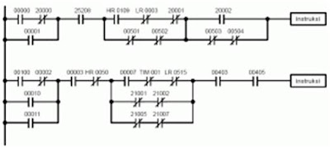The ladder diagram is an automatic control diagram language that was introduced since the PLC was developed to replace relay logic control systems, it was only natural that the initial language closely resembles the diagrams used to document the relay logic. By using this approach, simple switch circuits are converted to relay logic and then to PLC ladder logic. Any control task modifications are done by changing the program. This is why the use of PLC is preferred to the traditional hard-wired circuits in industrial controls.

Fig 4.1: Ladder Diagram

**4.2. Module Designing:**

We have used ZELIOSOFT2 V 5.4 to design our ladder diagram for the two-floor-based elevator control system. Within the module, we have given a DC supply of 12 Volts. This module consists of 10 Discrete inputs and 10 Relays as discrete outputs based on a real-time system. We have also 6 Mixed discrete or Analog Inputs varying from 0-10V in this considered module. As mentioned before, the programming language used here is Ladder Diagram. Last but not least this module is having reference SR3B261JD.

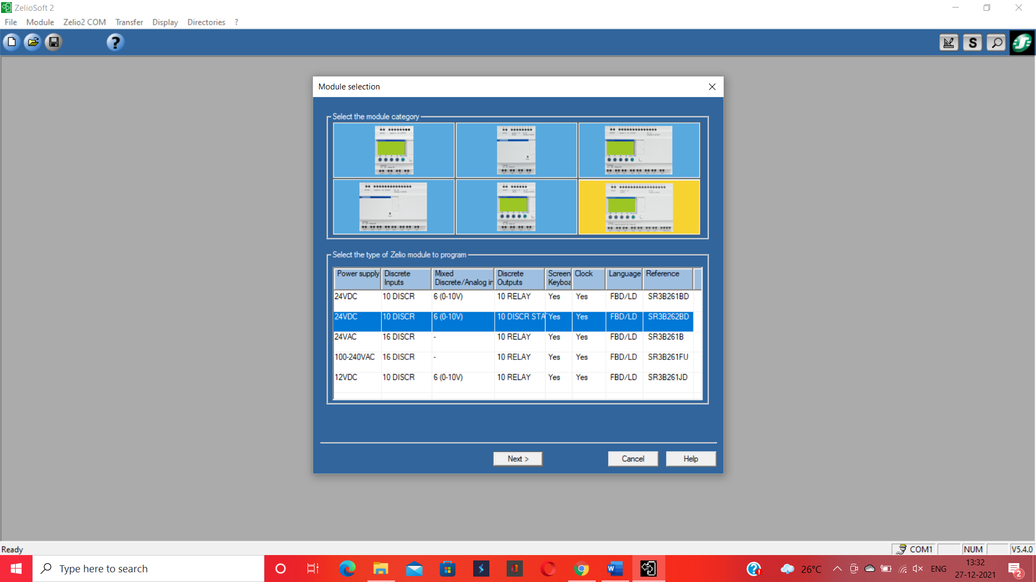

Fig 4.2: Model Description

**4.3. System Workflow**

In this elevator control system we have used only one single push button I1 as the main switch of our fully automated elevator which is basically a normally open discrete input switch. In this ladder diagram, we have used the simplest items such as on delay timers, off delay timers, output coils, memories, normally open switch, normally closed switch, and NO - NC contacts of our used memories, timers, and coils. A Direct ON Line Motor Starter (DOL) circuit is acting as the main controller of this whole automation process. We have used here 4 discrete output coils and 4 on-delay timers.

The symbols and their representation are as follows:

|  |  |  |
| --- | --- | --- |
| Symbols | Symbol Type | Representing as |
| I1 | Discrete input | Start button to run total system |
| I2 | Discrete input | Stop button to run total system |
| Q1 | Discrete Output | Motor to open the Elevator door at ground floor |
| Q2 | Discrete Output | Motor to go up from the ground floor to first floor |
| Q3 | Discrete Output | Motor to open the Elevator door at first floor |
| Q4 | Discrete Output | Motor to go down from first floor to ground floor |
| T1 | Timer | Timer to open the elevator door in the ground floor and going up of the lift at the same time |
| T2 | Timer | Timer to inform that lift has already reached in the first floor so stop the up motor and open the elevator door |
| T3 | Timer | Timer to close the elevator door at first floor and then make active the down motor |
| T4 | Timer | Timer to stop the down motor after reaching back to the ground floor and opening of the elevator door at the ground floor again |
| M1, M2, M3, M4, M5, M6 | Memory | Memories to store the past or present values of inputs and outputs |

* 1. **Designed Program:**

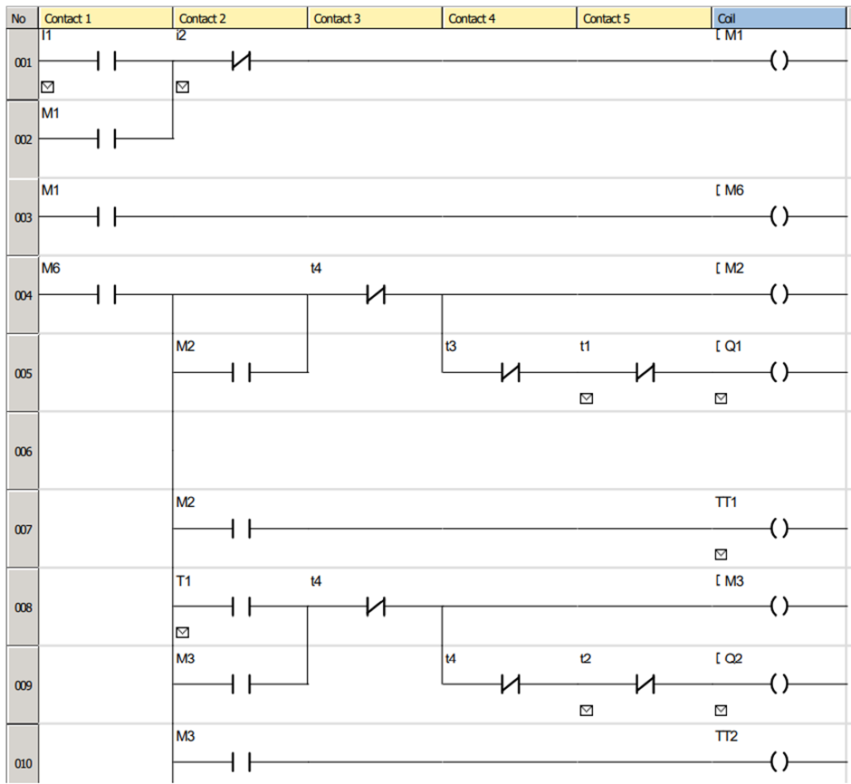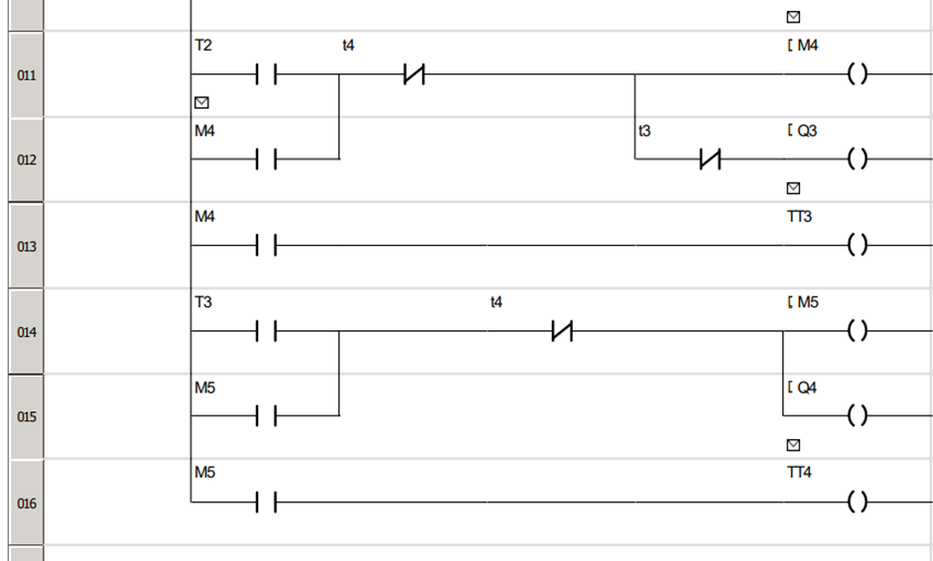

Fig: 4.4

1. **Experimental results**

Let us discuss the steps by which we can come to a conclusion that our designed elevator is a fully automated successful invention. As previously mentioned, between two push buttons I1 denotes the start Button. So, as we press it the current will flow through our DOL circuit, the main controller of the whole system. The blue lines denote current flowing through it, on the other hand, the red lines indicate current is not able to flow through it.

**Upward movement**

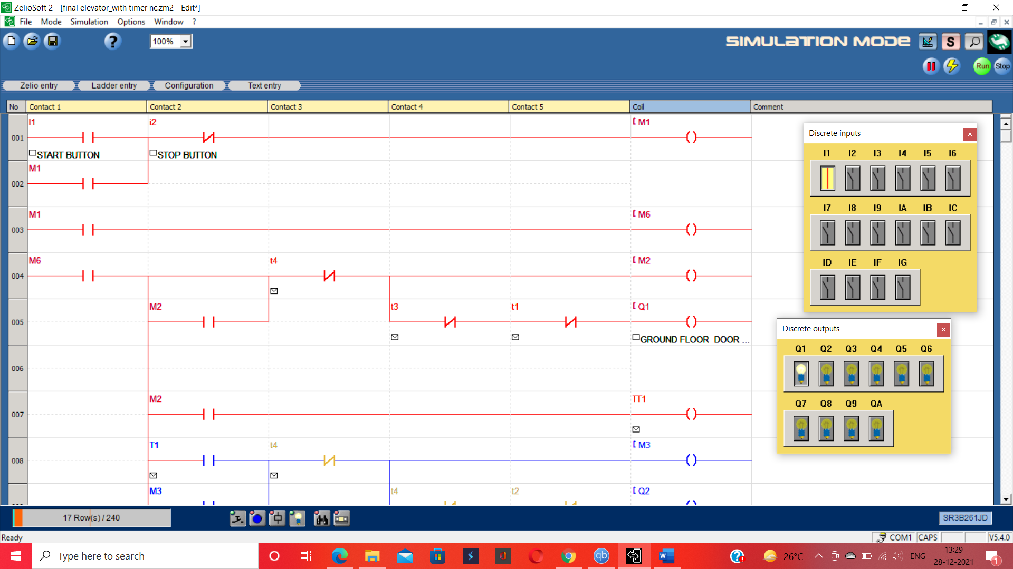As we can see in Fig; 5.1 as soon as the current flows Q1 is being ON which is indicating the motor for controlling the elevator door in the ground floor is being active and opened the door.

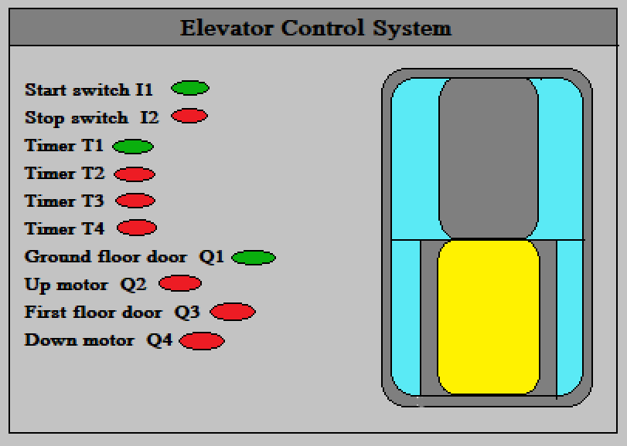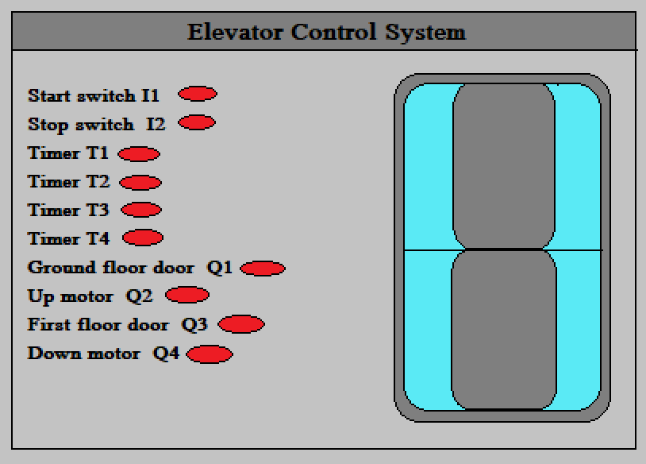

Fig: Stable Condition Fig: After turned on T1 being active

Fig: 5.1

Now comes the role of the T1 timer here. We have taken an estimated value of 8 secs within which all passengers, as well as goods, can enter the elevator comfortably. So, after 8 Secs the Q1 will go OFF indicating that the motor is going off by closing the door. As soon as Q1 goes off, Q2 goes ON indicating that after closing the door up the motor is active and as a result, the lift is going up in Fig: 5.2.

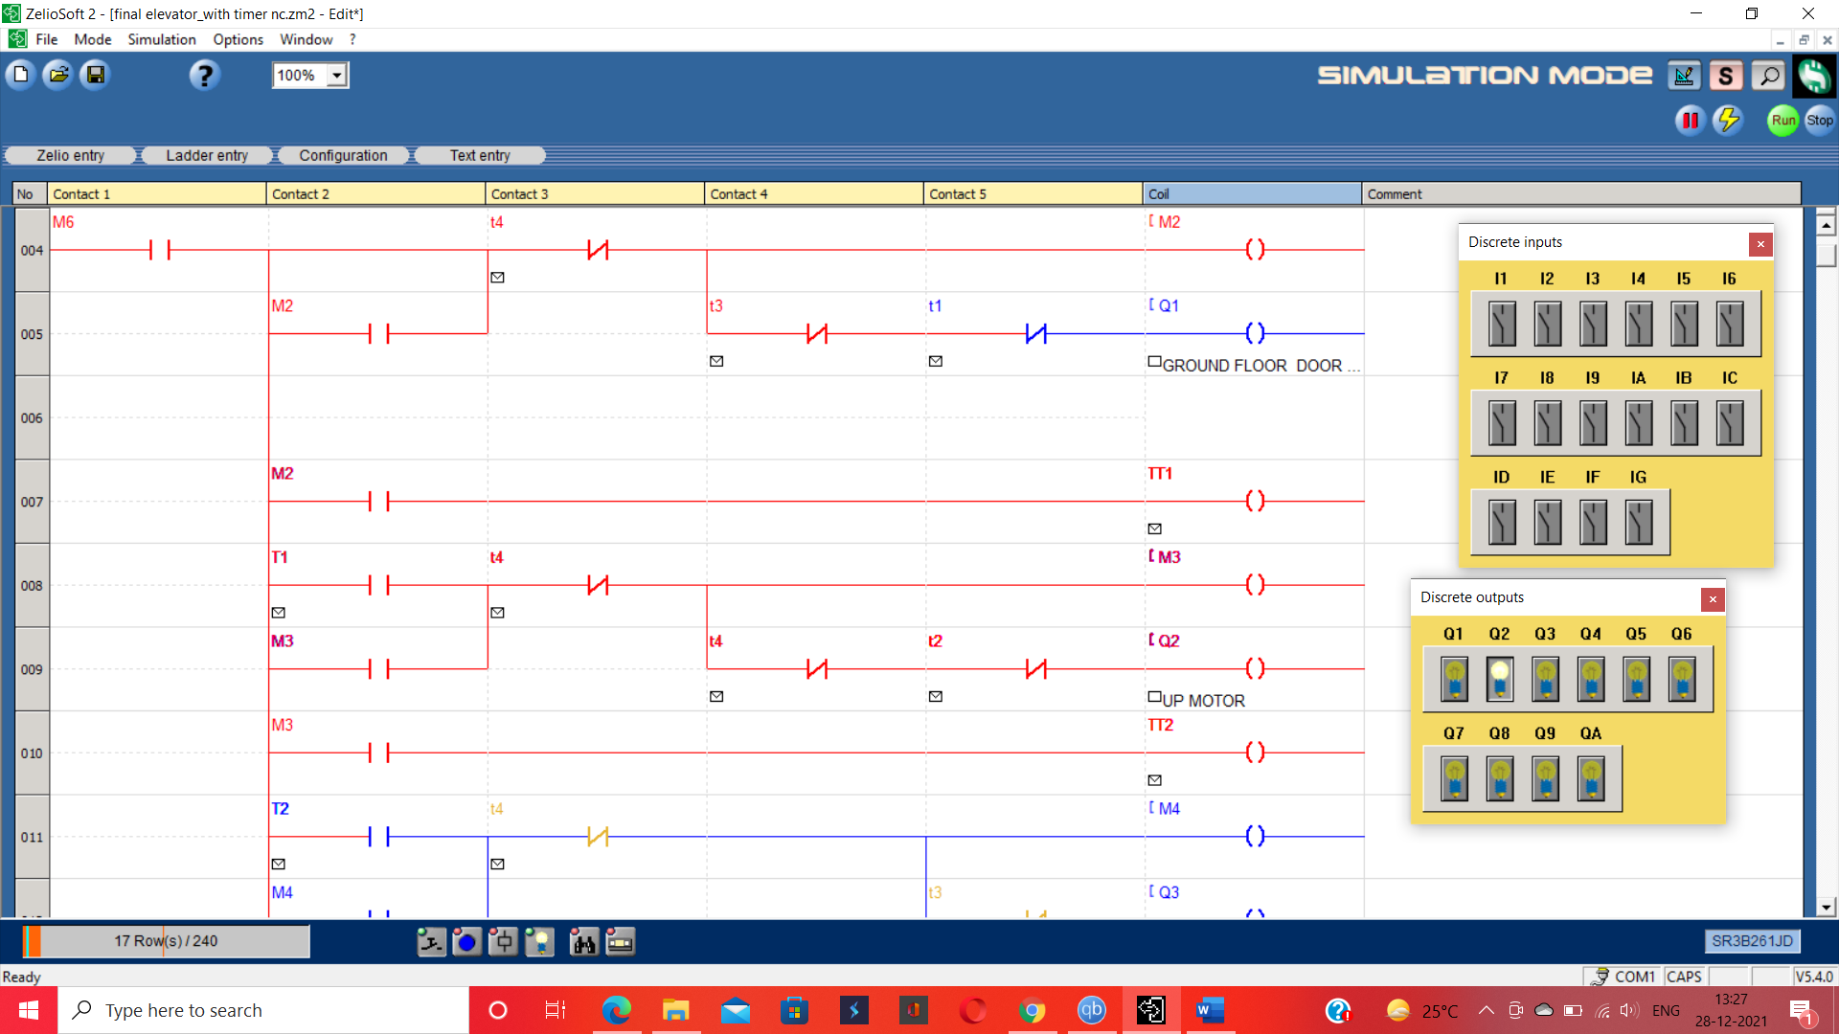

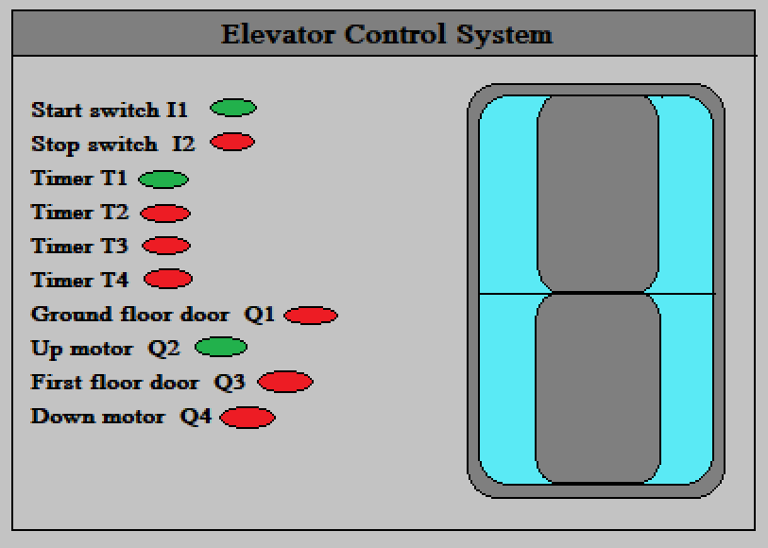

Fig: T1 making Q1 off and Up motor on after 8 secs

Fig: 5.2

Taking into consideration the capabilities of UP motor like motor velocity, capability to carry maximum weight, the vertical distance from ground floor to the first floor we came to the result that after 15 secs it will reach from ground floor to the first floor. Here comes the timer T2 which makes the Up motor Q2 OFF as in Fig 5.3. As soon as Q2 goes OFF, Q3 turns ON which controls the elevator door when it reaches the first floor.

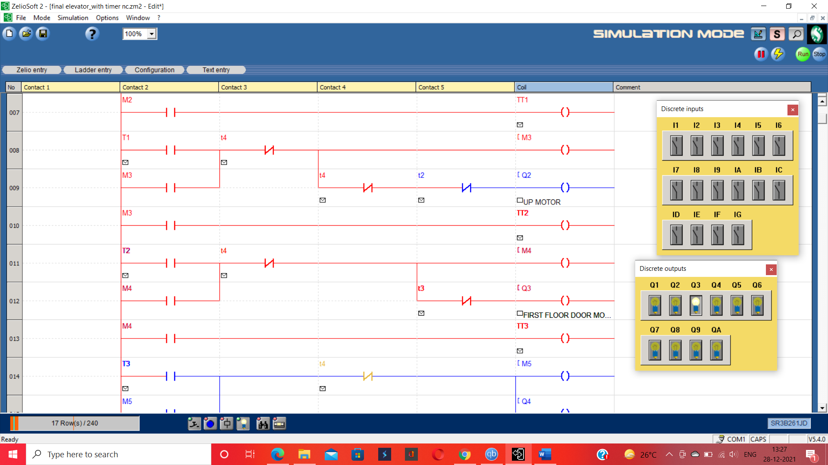

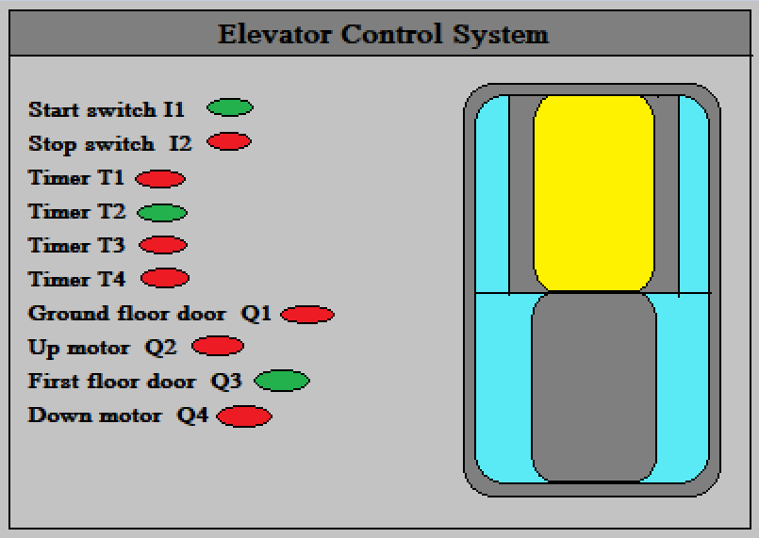

Fig: T2 making Q2 close and Q3 open after 15 secs

Fig: 5.3

**Downward Movement**

SO, as we are now in the condition of Q3 is ON indicating the elevator is in the first floor keeping its door open so that those who want to go to the first floor can exit and those who want to go to the ground floor from the first floor they can enter comfortably. We estimated a value of 8 secs. T3 takes the main role here to turn off Q3 and close the elevator door on the first floor. As soon as the door is off we have to go to the ground floor. So T3 is also turning on Q4 the down motor for downward movement in Fig 5.4.

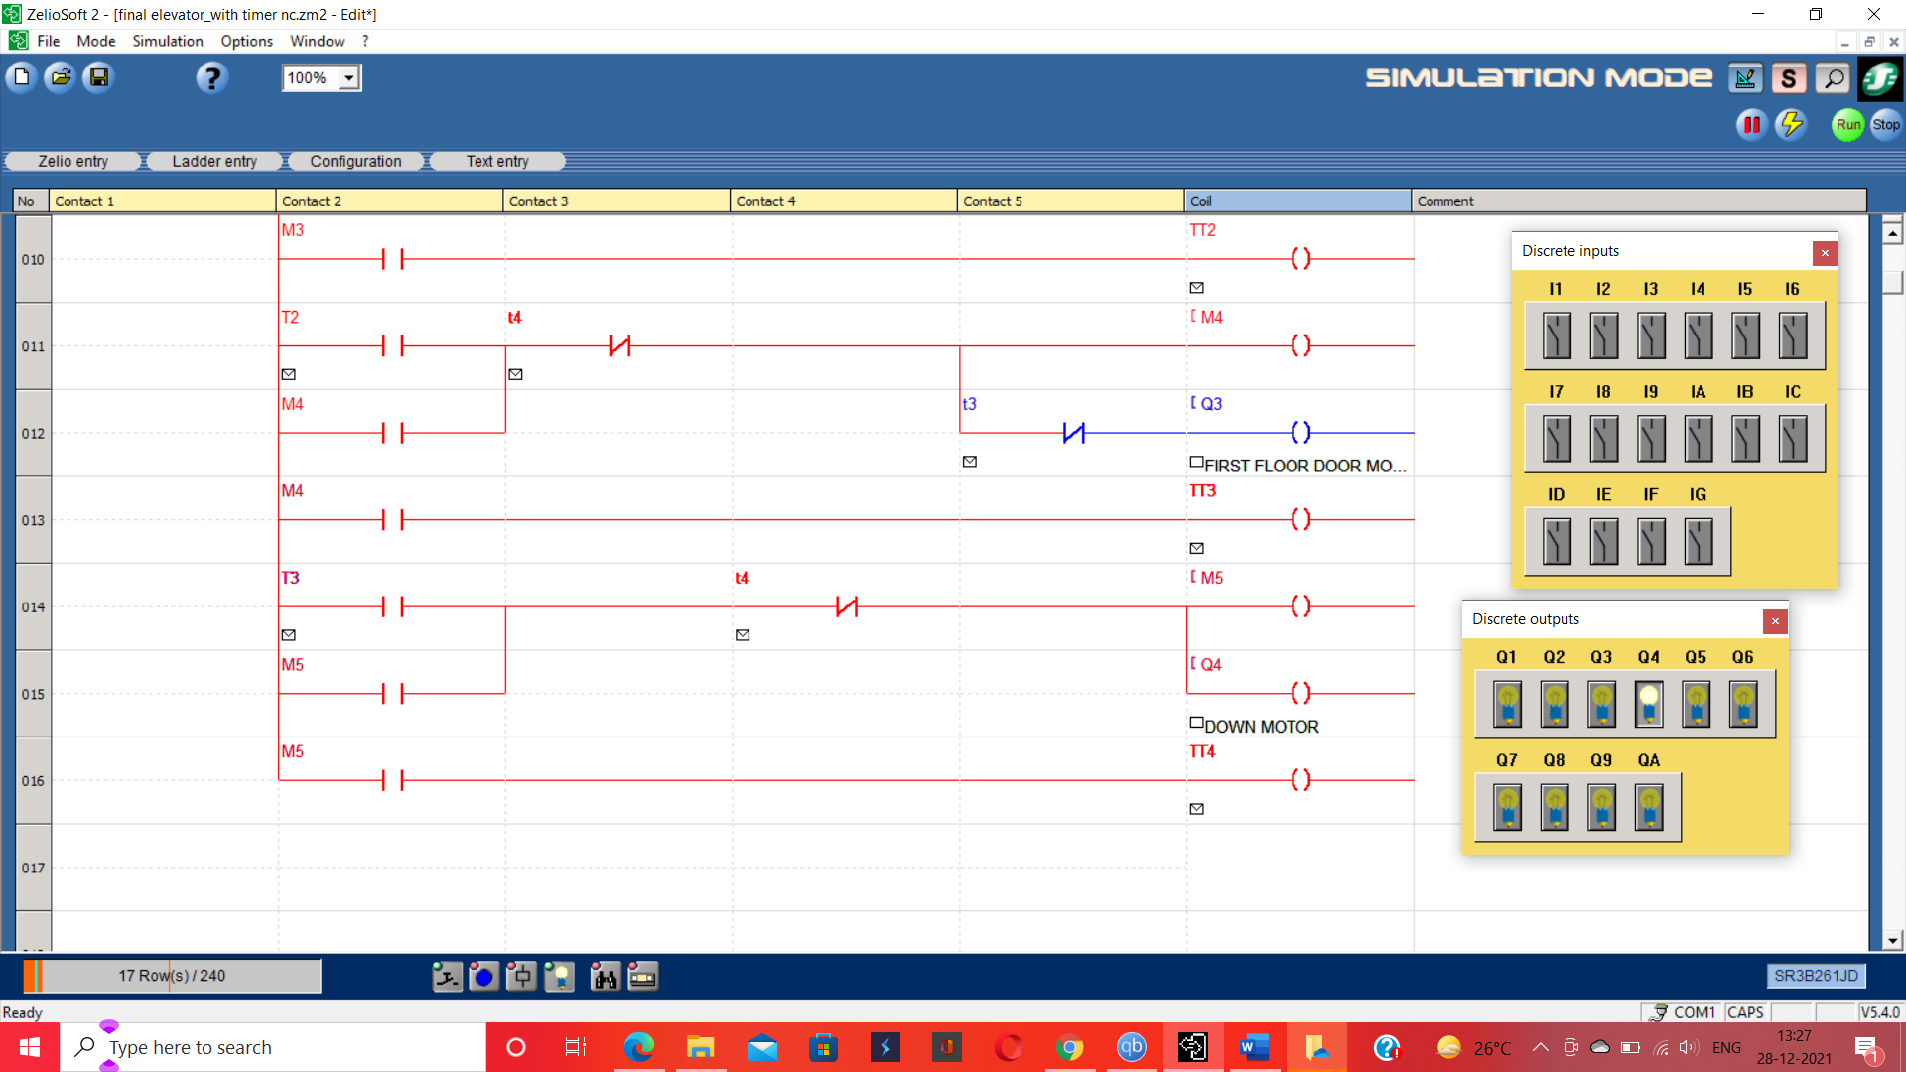

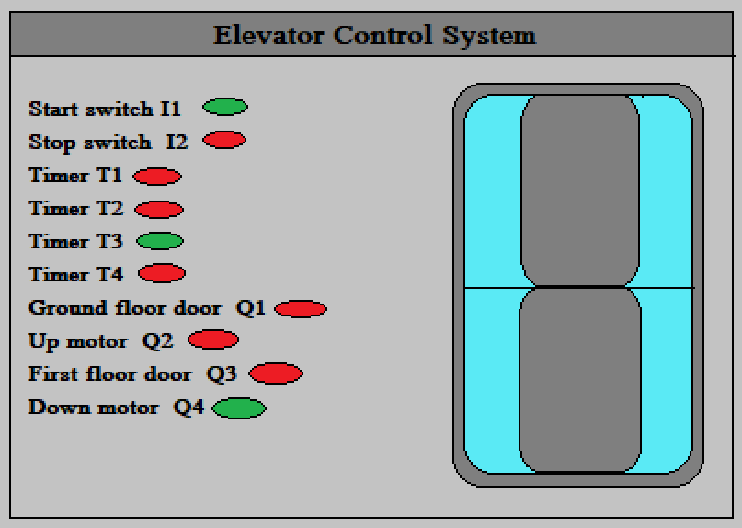

Fig: T3 making the Q3 Off after 8 secs and making on Q4

Fig: 5.4

As previously mentioned, our elevator takes 15 secs to go from one floor to another floor.SO, the T4 timer comes here to stop the down motor to stop the elevator after reaching the ground floor by turning OFF Q4 in Fig 5.5.

Now as we are demanding that our elevator be fully automated so we don’t need to press the main control button for each time movement. So we need to go for a cyclic process by which again Q1 becomes on and the process continues again what we have seen in Fig: 5.2,5.3 & 5.4. So T4 here not only stopping the down motor but also made Q1 active again to open the elevator door on the ground floor again. Like this, the cycle will go on by activating Q2, Q3, Q4 at the previously mentioned sequence.

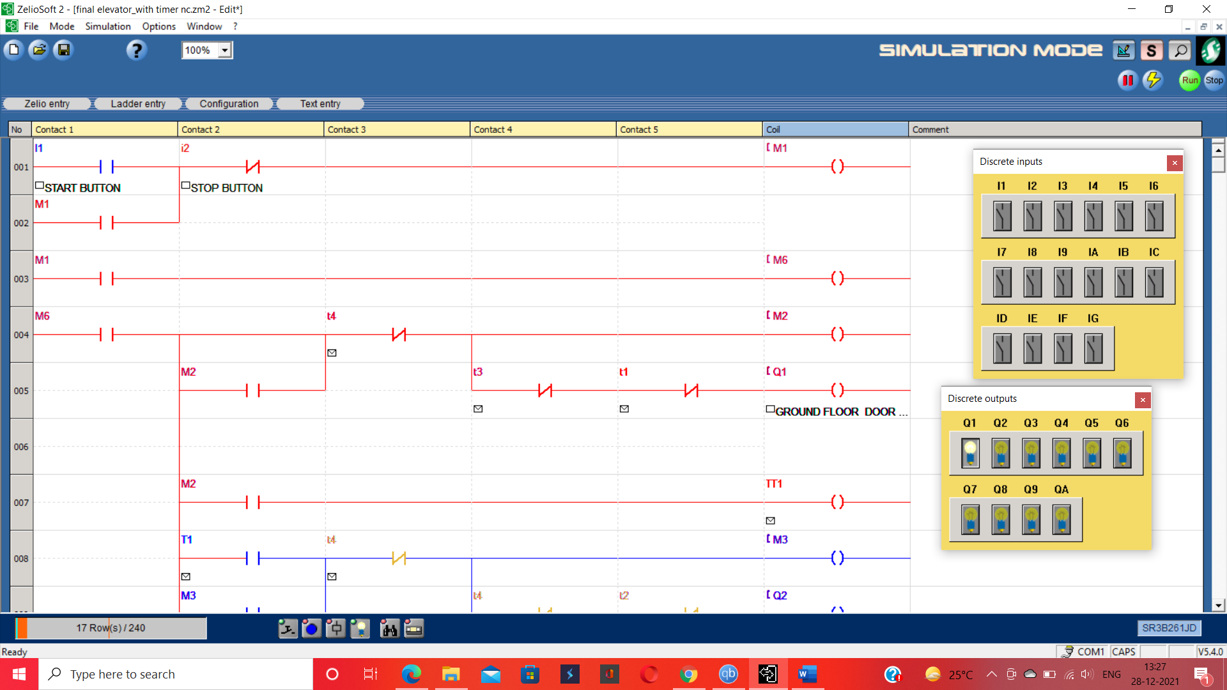

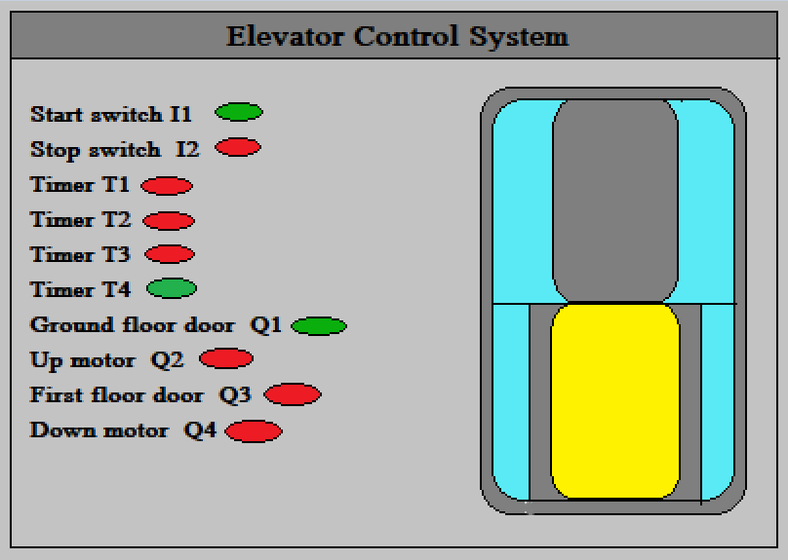

Fig: T4 making Q4 Off after 15 secs Fig: Again, Q2 being active after 8 secs

& Q1 being active again after making off Q1

Fig: 5.5

Off Condition: Now coming to the part when we don’t need the elevator, we should stop this to work automatically as saving electricity should be the priority. Here we have used the normally closed push button I2 to stop the whole control system. As we can see in Fig 5.6 when I2 is on no bulb is on i.e each and every motor is turned off.

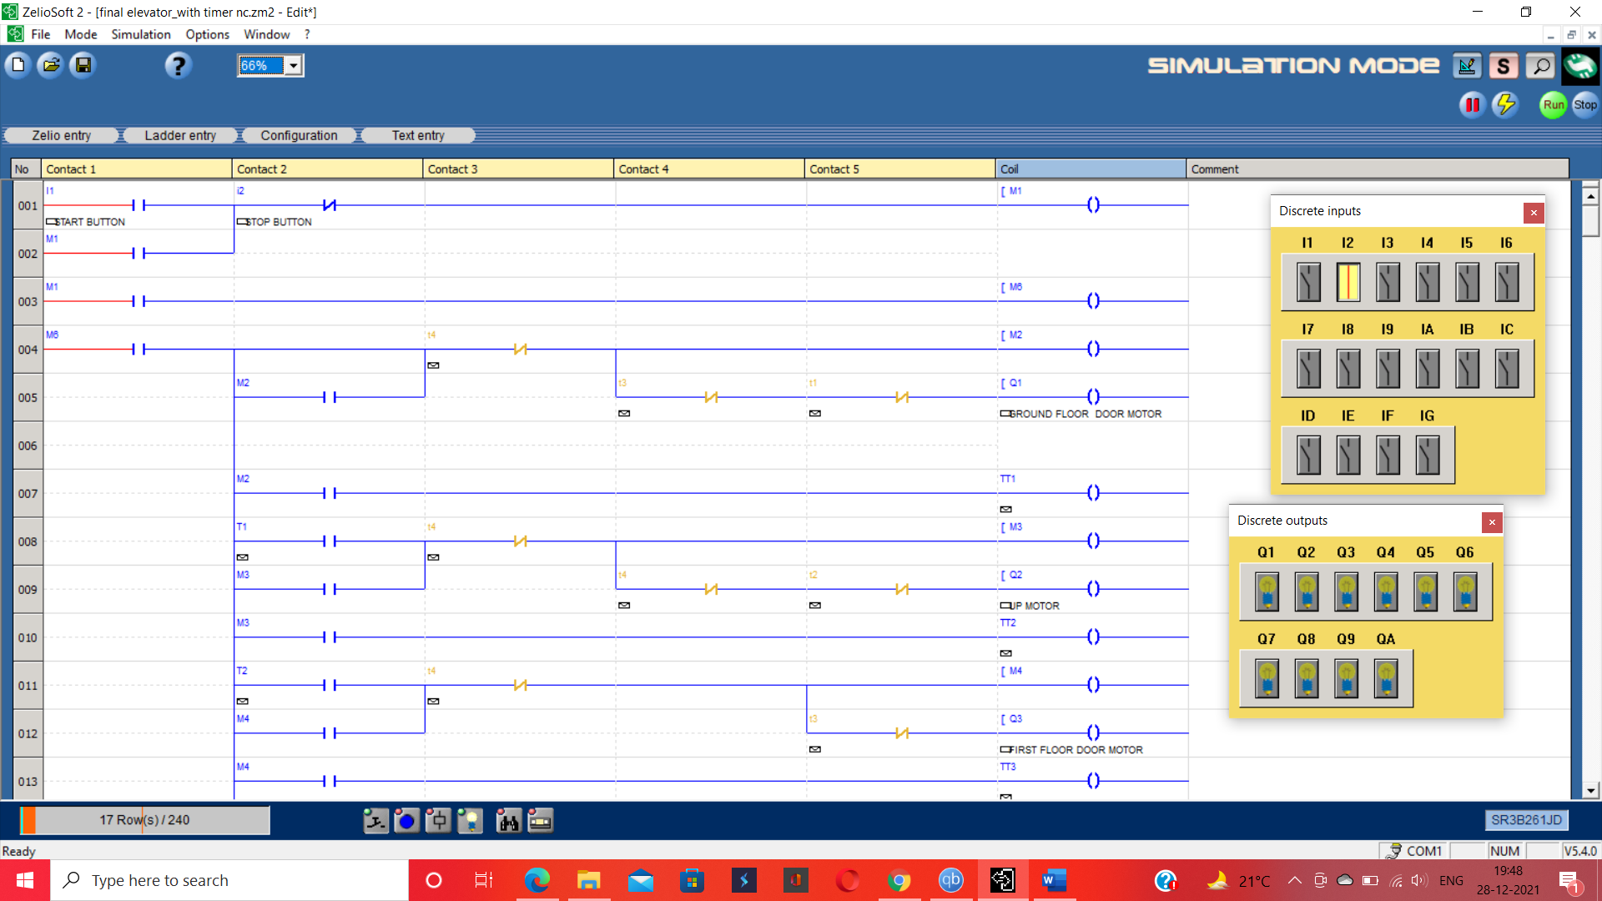

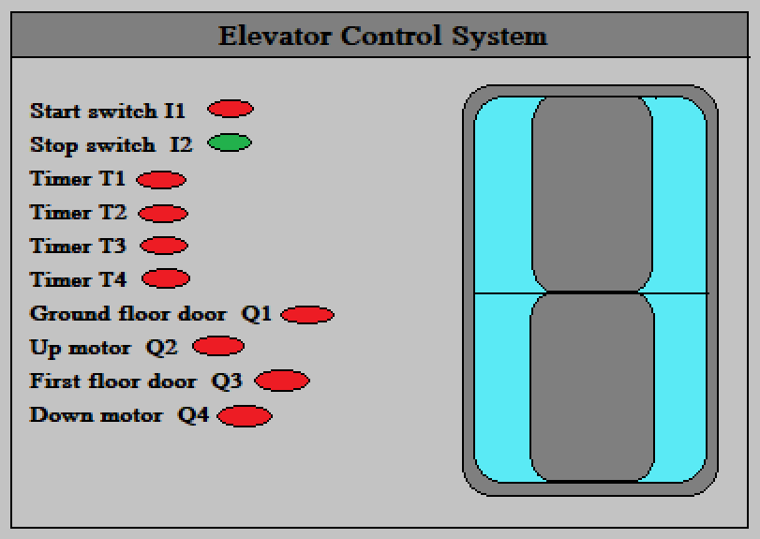

Fig: I2 Being On, total system shutdown

Fig: 5.6

**Conclusion and Future Scope**

With the rapid development of the social economy, the elevator has become a necessary product for building. The main characteristic of the elevator system is huge and complex, so in the research process of the elevator control system, it is difficult to fully and deeply understand the elevator system from the outside. The elevator control system based on PLC is easy to learn and operate, the language level control is flexible and convenient, and the operation is reliable and stable.

This paper describes the implementation of two-floor elevators in Zeliosoft2 software. Also, sensors, pushbuttons, actuator connection, and their configuration at different floors are effectively turned into the ladder logic network to implement the design into the simulation.

door opening and closing, and motor operation have been included in the logic and interpreted effectively through the simulation methods implemented.

It is observed that the PLC-based controller for the elevator works better than the other control systems. The industries and other business establishments will be greatly benefitted from this type of control system. However, before pressing this type of control system for commercial use, in-depth study, experimentation, and validation is required.

This model can be improved further as described below:

* Implement some techniques like Floor-Having-More-People First, by adding a weight sensor to each floor, to know which floor has the maximum crowd, and a different sensor to make the journey more comfortable.
* Nano PLCs can also be interfaced with an elevator.
* Use of Solar Energy for the elevator control system.

Although the application of PLC technology has been very extensive, there are still some problems. We still need to continue to study and explore and further improve the application of PLC technology in the elevator control system.

**REFERENCES**

1. Design and Implementation of an Electrical Lift Controlled using PLC By Mohammed H. Ali, Electrical Power, and Machines Engineering Department, Diyala University, Iraq, August 2018.

2. Design and research of elevator control systems based on PLC. ByXiaohu Han, PetroChina West Pipeline Company, Urumqi, 830013, China, 2020

3. Application of PLC for Elevator Control System. By Saurabh Sharma, Assistant Professor-II, Mech. Engg. Dept.SMIT, Majitar, T.Y.Ladakhi Assistant Professor-II, Mech. Engg. Dept.SMIT, Majitar, A.P.Tiwary Associate Professor Mech. Engg.Dept.SMIT, Majitar, Dr. B.B.Pradhan, Professor Mech. Engg. Dept. SMIT, Majitar R.Psiphon Associate Professor Mech. Engg. Dept. SMIT, Majitar

4. Design of a PLC Based Elevator Control System byA M Anusha* and Ashok V. Sutagundar Department of ECE, BEC, Bagalkot,2015

5. Design & Control of an Elevator Control System using PLC by Prof. Omkar M. Shete1, Ms. Amrita A. Vitekar2, Ms. Ashwini N.Patil3, Assistant Professor, Electrical Engineering Department, NBN Sinhgad School of Engineering, Pune, India 1, Student, Electrical Engineering Department, NBN Sinhgad School of Engineering, Pune, India2,3, April 2017.

6. Implementation of a Four-Floor Programmable Logic Controlled Elevator System by KAMALU, U.A, OGUNLEKE, F.A, June 2018.

7. Design and Implementation of PLC-based Elevator by S.B. Ron Carter Dept of Electrical and Electronics Engineering, Rajalakshmi Engineering College, Chennai, India.A. Selvaraj Dept of Electrical and Electronics Engineering, Rajalakshmi Engineering College, Chennai, India.April 2013.

8.Implementation of PLC Based Elevator ControlSystem by Sandar Htay 1, Su Su Yi Mon, Department of Electronics Engineering, Mandalay Technological University(MTU), Myanmar.

Rangani D G, Tahilramani N V. Automation-based elevator control system[C]// International Conference on Applied & Theoretical Computing & Communication Technology. 2018.

JayawardanaH.P.A.P., Amarasekara. H.W.K.M., Peelikumura.P.T.S., Jayathilaka. W.A.K.C., Abeyaratne.S.G. and Dewasurendra. S.D.“Design and implementation of a statechart based reconfigurable elevator controller”, 6th IEEE International Industrial and Information

Systems, IEEE Conference Publications, pp. 352-357.

Chakraborty, K., Roy, I., De, P. and Das, S., 2015, “Controlling the Filling and Capping Operation of a Bottling Plant using PLC and SCADA”, Indonesian Journal of Electrical Engineering and Informatics (IJEEI), vol. 3, no. 1, pp. 39-44.

Srinivasan, K., Vijayan, S., Paramasivam, S. and Sundaramoorthi, K., (2016), “Power Quality Analysis of Vienna Rectifier for BLDC motor Drive Application”, International Journal of Power Electronics and Drive Systems, vol. 7, no. 1, p.7.

A.C., Vidanapathirana. S. D. Dewasurendra and S.G Abeyratne, (2011), “Statechart based modeling and controller implementation of complex reactive systems”, 6th IEEE International Conference on Industrial and Information Systems, pp. 493-498.

Sale M D, Prakash V C. Dynamic Scheduling of Elevators with Reduced Waiting Time of

Passengers in Elevator Group Control System: Fuzzy System Approach[M]// Innovations in Computer Science and Engineering. 2017.